# Job Aid: Documenting the Sites you are following

The legacy Hillshire HuB is moving to the Source. Saved favorites and site that you are Following will not be tracked and moved as part of the migration. Please follow the steps below to capture the URLs for all the sites you are following. We have created a template that can be used to determine the new URL for the site.

## Following Sites

*Complete these steps before the freeze.* ***After the freeze, this information will no longer be visible****.*

1. From the HuB home page, select **Sites.**

1

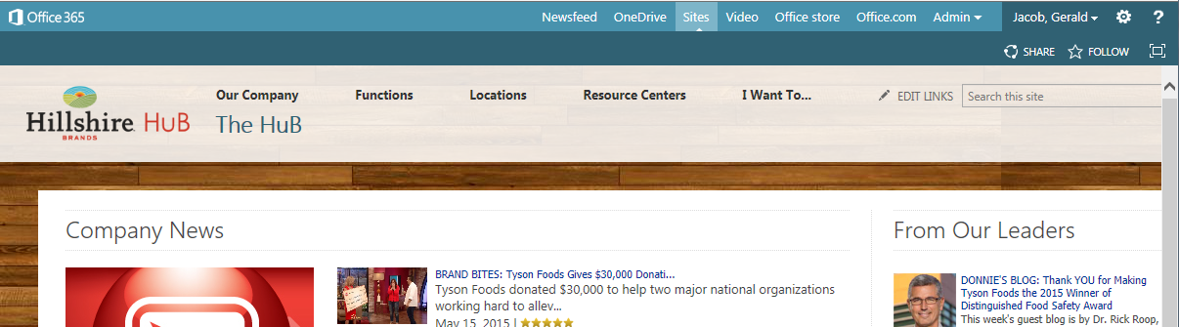

1. The **Sites** main page will open displaying a list of “Sites I’m following”.

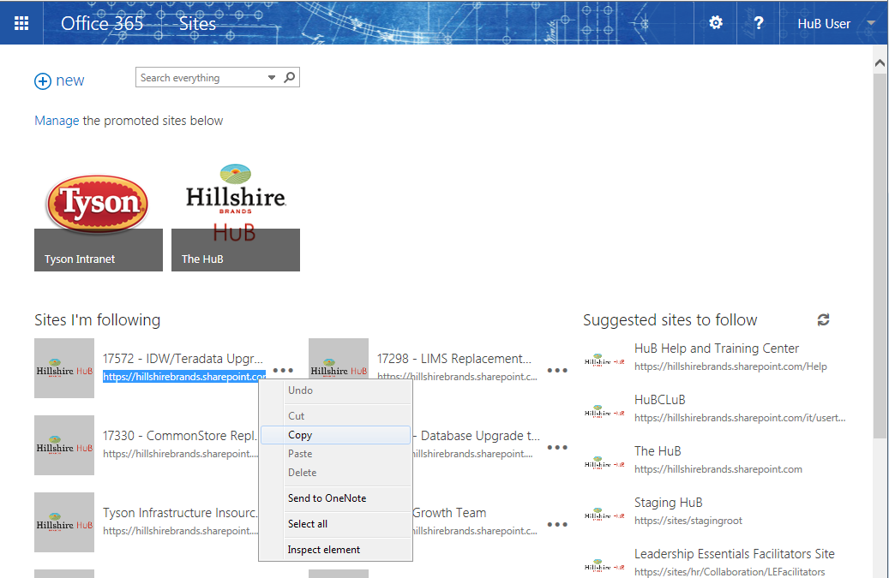

3

2

1. Right click on the URL for one of the site you are following. When the menu opens, select **Copy.**
2. Open the attached excel file.



1. Paste the HuB URL in Column A in the excel file.

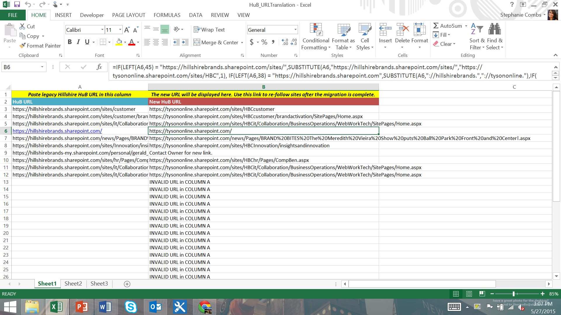

6

5

1. The new HuB URL will be displayed in Column B
2. Save the excel file to your computer. Once the migration of the HuB is complete, you will need to use the auto-generated Tyson URLs to re-follow you favorite sites.

## Re-Follow Sites on the Tyson HuB

1. Login to the HuB on the Tyson Source using your Tyson credentials.
   1. <https://tysononline.sharepoint.com/sites/HuB>
2. Open the Excel file you used in Steps 5 and 6.
3. In the URL banner paste a link from Column B.
   1. Note the link should contain tysononline.sharepoint.com.
4. Once the site loads, select **Follow**.



4

1. You are now following the site. The icon should change from Follow to Following.
2. Repeat steps 3-4 for all sites you want to follow.